**POWER EFFICIENCY USING MACHINE LEARNING**

**1.UNIQUENESS:**

In our proposed work, a power sensor(ACS712 30A module which is around 180 rupees, can accurately detect AC or DC current.The maximum AC or DC that can be detected can reach 30A.)is connected to each and every device in a household. For example, separate power sensors for lights and fans can be used because it is cost efficient and detects the value accurately and the values detected will be sent to the database using node Mcu.The cost and energy consumption for the next month is predicted using machine learning’s Linear regression algorithm. In this way, the wastage or any fault in the components can be detected by the algorithm since there will be a peak in the prediction wavelet. furthermore the energy can be diverted to the systems needing more energy.For example, some industries require more power for their process whereas in some households energy units might not have reached the allocated limit,so this excess of energy units can be diverted to industries. The interface of the system we have developed is user friendly and it is easily accessible by the user and the power providing sectors. The live tracking of the energy utilized in the household helps us to calculate the cost for the respective consumption ,The cost is calculated using the formula watts*hours used*price for the units.After implementing our project,the cost for the households can be minimised significantly.The cost is minimised significantly because the energy consumption will be reduced.

**2.IMPACT ON BUSINESS:**

In many places both small scale business and large scale business are affected by electricity shortage.This has an impact on the economy of the country.Electricity shortage has been one of the biggest problems in the industrial side.So diverting the energy units from one system to another requiring system plays a major role in this part.

* 1. This system solves the problem of electricity shortage upto a level.
  2. Viewing the usage of electricity in industries is easier,since they will have a separate login to view the usage .
  3. Power wastage can be avoided
  4. Faulty systems can be easily identified.
  5. This system has a major impact on the business sectors as they get the required power for their processes.
  6. If there are no problems regarding electricity for the industries, it might help them to improve the overall production.

**GENERAL OUTLINE OF THE SYSTEM:**

Figure 1:Depicts the outline of the proposed system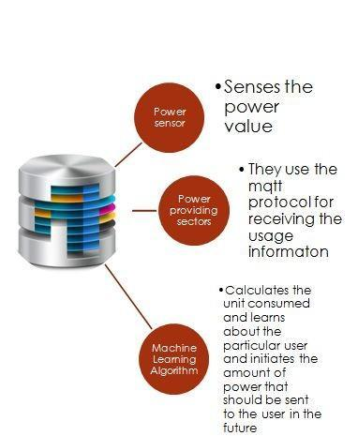

3.**ARCHITECTURAL FLOW AND TECHNOLOGIES USED:**

The Technologies used in the system are listed below:

1. **Machine learning algorithm** - used for predicting the units consumed and the amount we have to pay.Linear Regression algorithm is implemented. (name the algorithm and methodologies, tools to be used )
2. **Internet of Things**- IoT devices are used for detecting the power consumed in the household and it is sent to the database (which sensor and its model, make).
3. **Python**- Coding is done in Visual studio environment and the programming language chosen is python.It is used for coding the algorithm and it is also used for retrieving data from the database.Other than python, R language can also be used, or Octave environment can also be used .Python language is chosen because of the following reasons,
   1. Less code
   2. Built in libraries
   3. Platform agnostic
   4. Flexibility
   5. Easy to compile and run
4. **Python_FLASK** - This API acts as an interface for transferring the data with the help of **javascript**.
5. **SQL Database -** SQL database is used for the data storage as well as sending the data (predicted value and the costs) to the webpage for displaying.The preprocessing is done in flask server and then the data is being sent to the database.From the database the website receives the data
6. **SCIKIT LEARN** - It is used for implementing the machine learning algorithms. We have used some predefined dataset for testing the accuracy of the algorithm.Datasets are initially taken from kaggle website and then it is truncated and cleaned to use in scikit learn.

The architectural flow of the system proposed is shown below.

**ARCHITECTURAL FLOW OF THE SYSTEM:**

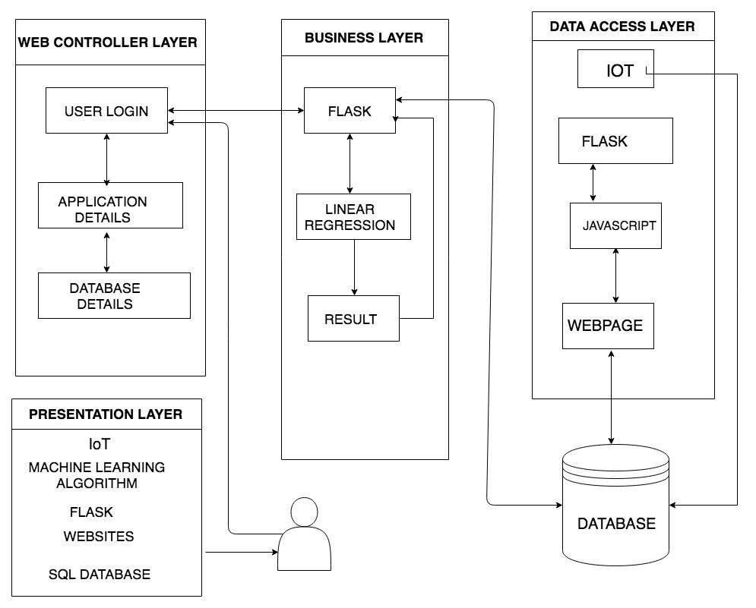

Figure 2:Architectural flow of the system

**4.MODULES**

1. IoT DEVICES
   * IoT devices consist of power sensor(ACS712 30A module),Relay module,NodeMcu(It includes firmware which runs on the ESP8266 Wi-Fi SoC from Espressif Systems, and hardware which is based on the ESP-12 module.)
   * **PART 1:Cost efficient method:**
     + We connect the Power sensor to the energy meter in the house,and get the values of energy consumption.This values are sent to the SQL database using NodeMcu module.
   * **PART 2: Little bit costly:** 
     + If the user is ready to spend extra money for accuracy, We can connect power sensor in each and every switch boxes in the house and get the values of voltage and current utilized for each device concerning that particular switch box. Then this data is sent to SQL database.

2. DATABASE

1. We get the values from the IoT devices and store it in the database.
2. Simultaneously we also store the values we get from the algorithm (predicted values from linear Regression).This data is sent to the website for the user's perusal.

3.USER INTERFACE

* 1. The User can log into this website to see the monthly and daily usage of the power in his/her household.
  2. The application details section prompts the user to enter the details of the appliances and the hours for which it has been used.

4.MACHINE LEARNING ALGORITHM

* 1. The values in the database are fed to the machine learning algorithm’s dataset for the prediction of cost and the prediction of units which will be consumed.
  2. For predicting the cost and power consumed we have used Linear Regression.
  3. After predicting the cost and the power consumed this data is sent to the website for the user's perusal.

The Workflow of the proposed system with the modules has been shown below:

**WORKFLOW OF THE ENERGY PREDICTING SYSTEM:**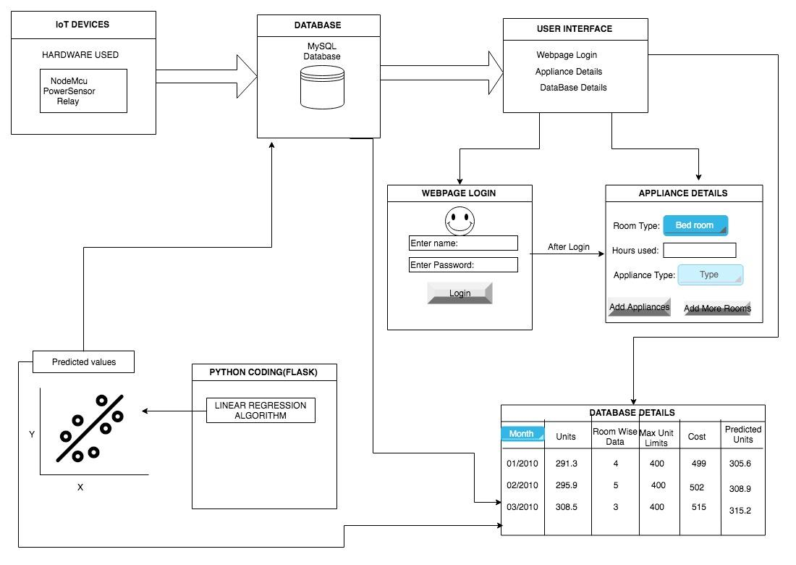

Figure 3:Workflow of the system